Online Shopping Project & Callback Function

1. Online Shopping Cart
Description: This project allows users to add products to a cart. The cart count increases each time a product is added and resets when cleared.
Code:
let cartcount = 0;
function addtocart(){
cartcount++;
document.getElementById("cart-count").innerText = cartcount;
}
function clear1(){
cartcount = 0;
document.getElementById("cart-count").innerText = cartcount;
}
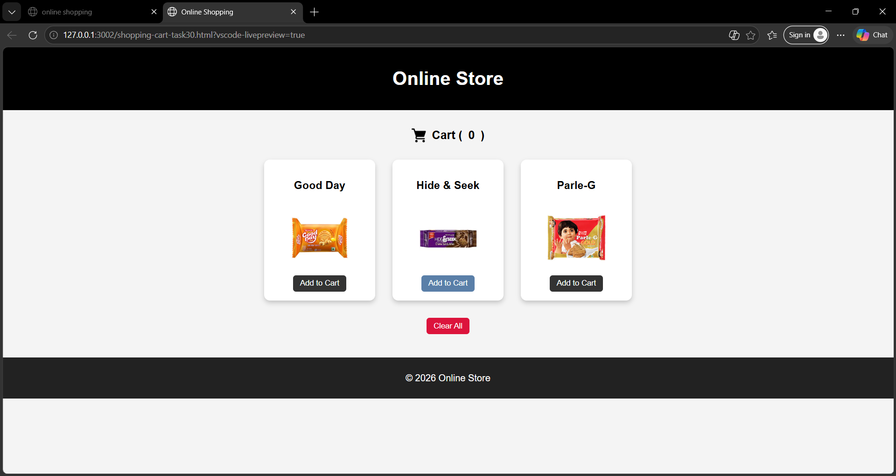
OUTPUT:

2. Callback Function
Description: A callback function is a function passed as an argument to another function and executed later.
Code:
function orderprocess(callback){
console.log("order processing");
callback();
}
function ordercompleted(){
console.log("order completed");
}
orderprocess(ordercompleted);

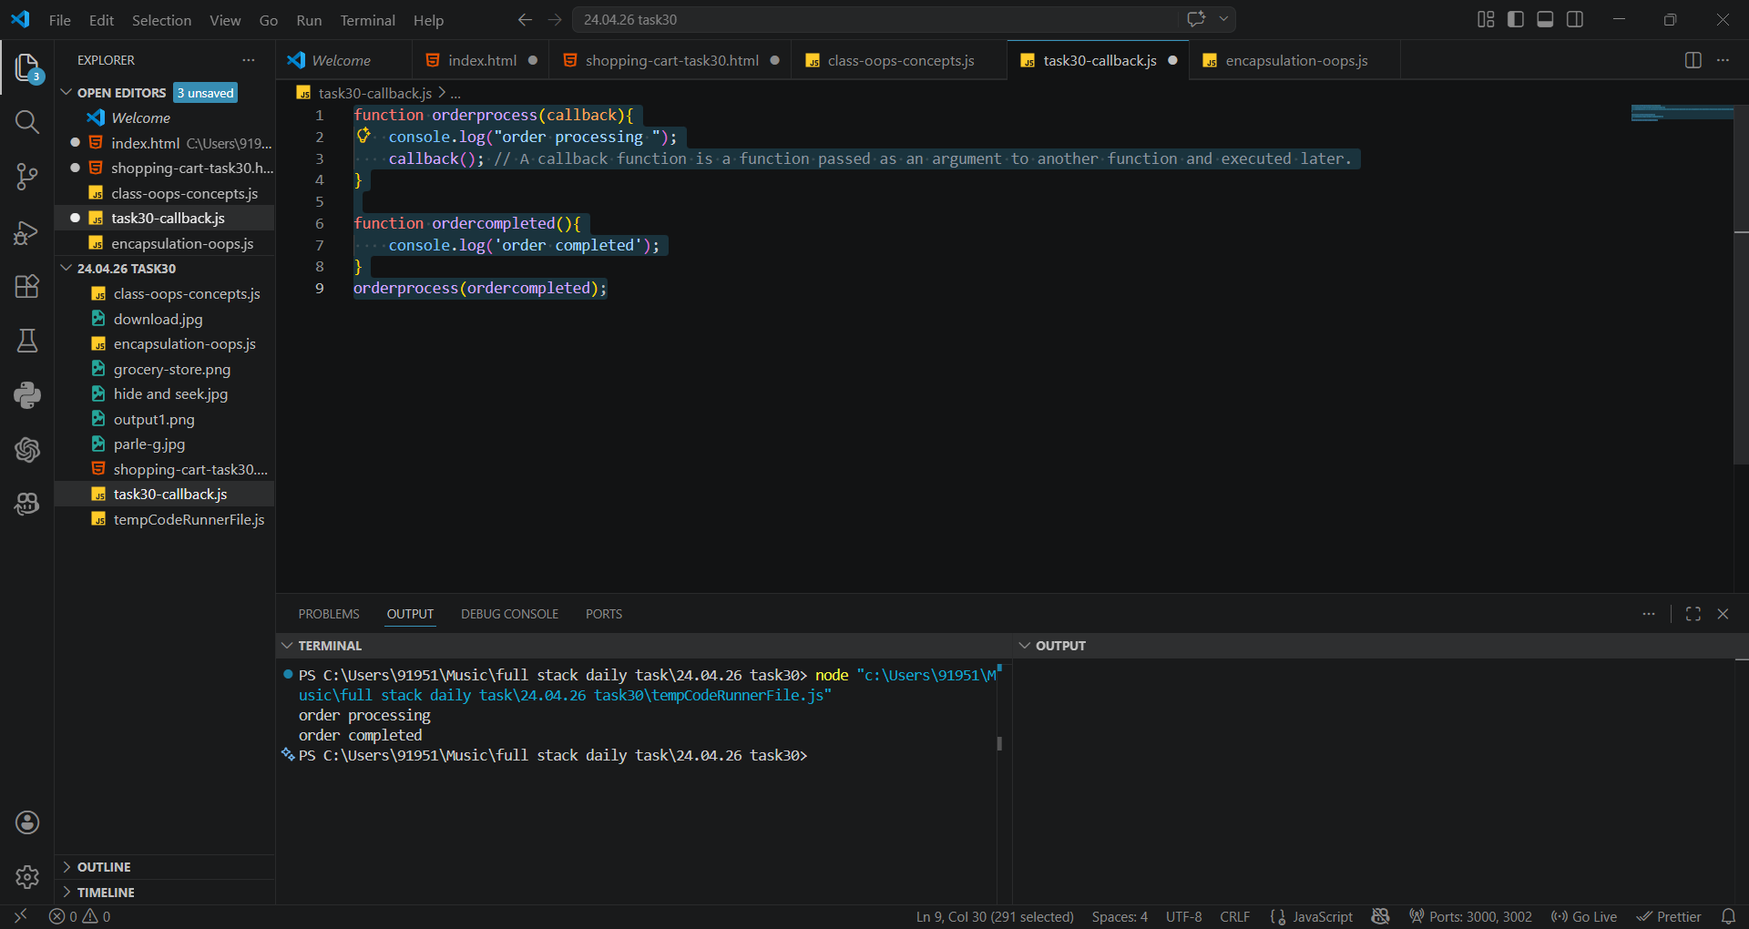
OUTPUT:

